INSTALLATION OF PYTHON 3.11

**TEAM ID:**  PNT2022TMID50986



**PROJECT NAME:** PERSONAL ASSISTANCE FOR SENIORS WHO ARE SELF RELIANT

1. Type Python in Google and Click the first link

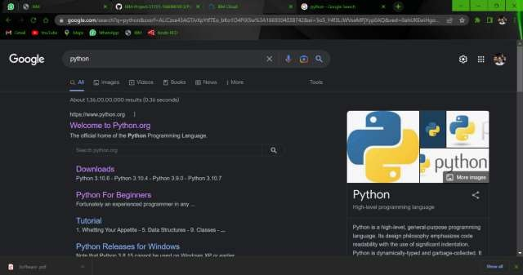

1. Click Python 3.11

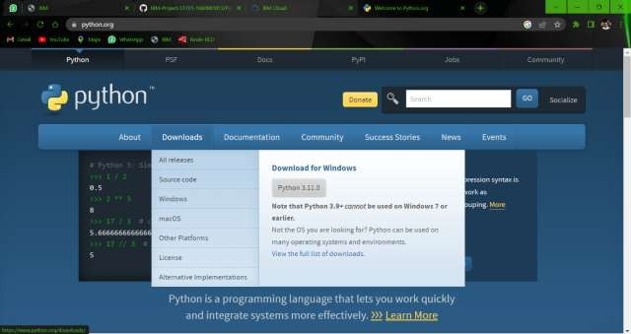

1. Click the IDLE (Python 3.11 64-bit)

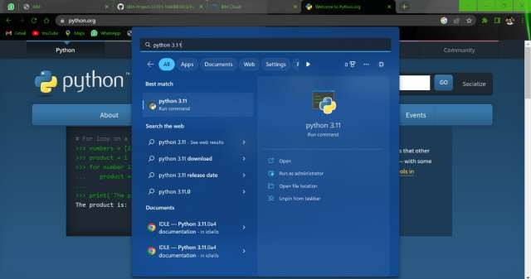

1. This is the IDLE Python (3.11 64-bit)

